Thursday 27th July
Dear Parents/Carers
I hope you have had a happy summer and have been able to enjoy being out and about while keeping safe.
There have been few changes to the guidance (last updated 7th August) about returning to school in September and this clearly sets out the public health advice schools must follow to minimise the risks of coronavirus (COVID-19) transmission. It also includes the process that should be followed if anyone develops coronavirus (COVID-19) symptoms while at school or at home. The following is an update to the information I sent out before the summer break and explains how the school will be following the guidance and keeping the children and adults as safe as possible through enhanced hygiene, distancing between bubbles (classes) and restrictions on visitors.
The DFE have information for parents/carers about the return to school which you may find useful: gov.uk/backtoschool
Car Park –drop off and pick up.
I have re-attached the car park arrangements for drop off and pick up. Unfortunately there can be no exceptions to these arrangements as it is very detailed and complicated to manage. Whilst we understand that this is not ideal, it is the only way that we can manage the amount of cars/adults and the need for separation of the bubbles; we ask for your continued understanding and patience. We will review this system after a few weeks. Please make sure you are familiar with these and share them with anyone who also has responsibility for bringing your child to school. It is vital that you keep to the times arranged. All the staff will be on duty every morning and after school to support with the smooth and safe handover. Most importantly –if you are late, DO NOT park in the car park. Park in the road leading to Tiptree opposite the school and telephone for Mrs Gooday to come and meet your child at the front gate. She will then see them into the school.
Can we come into school?
At this stage parents must not come into school without an appointment.
This will all feel very different and a little sad for all of us as we are such a friendly community and enjoy catching up with each other. However, for the safety of all we will not be allowing parents onto the school site unless by prior arrangement. Do not try to talk to the staff while they are supervising the car park. Please telephone the school or write a note in the home school diary if you have any queries or need to pass on a message to the class teacher/LSA. If you would like an appointment with a teacher, Mrs Lewis the SENco or myself please call the office and we can arrange a zoom meeting, a telephone call or a person to person meeting outside in the pagoda at the front of the school. If it is an urgent situation, call the school and I will come out to meet you in the pagoda straight away if possible. We aim to continue our close partnership working with you over these challenging times. We will be restricting the visitors allowed on site (such as trades and deliveries) and all visitors will be informed of the rules they need to follow in respect of hygiene and social distancing. Visits by prospective parents will take place towards the end of September in accordance with strict protocols.

What if my child is ill?
PHE (Now National Institute for Health Protection) have advised that implementing regular temperature checks is an unreliable method of checking for coronavirus and we will not be checking pupils’ temperature at this stage.
The current measures in place where someone has symptoms continue to apply and children will be isolated, pending pick up, with an adult to supervise them (at a 2m distance) in a well-ventilated room. The child should not return to school until negative test results are received. Tests can be booked online or home testing kits can be ordered. Book a test The government has confirmed that schools will be provided with a small number of testing kits for pupils with symptoms and we await further details.
Where there is a confirmed case of coronavirus in the School, we will work with the health protection team. The process will effectively be in line with the NHS Test and Trace system: those who have been in close contact with the case will be identified and asked to self-isolate. Local health protection teams will liaise with the School and where there are a number of cases, they may advise that further precautionary action is taken, which could include asking a whole year group or part of the School to self-isolate. We hope that the multiple precautions we have taken will avoid the likelihood of such occurrences.
If your child has Covid-19 symptoms, they should not come to school but should self-isolate while you have them tested. Please inform the School. If the test is negative, your child may return. If positive they should self-isolate for at least 10 days. Again, please let the School know so that we can take appropriate steps.
If somebody in your household has Covid-19 symptoms, please do not send your child to School, but inform the School and await the result of the test. If negative, the child may return to School; if positive they should self-isolate at home for 14 days.
If your child or a member of your household is identified by NHS test and trace as a ‘close contact’ of someone with symptoms or a confirmed case of Covid-19, please follow guidance from NHS Test and Trace and keep the School informed.
Where individuals or groups of pupils need to self-isolate, or there is a lockdown requiring pupils to remain in their household, we will be in a position to provide remote teaching and learning as we did during lockdown.
How will the children be organised?
The children will continue to be in their bubbles, but the size of a bubble will now be whole class. There is no longer a 2m social distancing requirement within bubbles but we will encourage distancing as far as this is possible. This means that the children in different classes will not be mixing at lunch and break times and there will be no whole school meetings such as assemblies. We are aiming for whole school praise assemblies via zoom and other assemblies held in classes.

Due to the very small size of the EYFS area we will be organising the children as follows for the Autumn term initially:
- Reception to be based in the hall and use the EYFS outdoor space.
- Class 1 to remain in class 1 and also have the option of a small group/s accessing the EYFS room.
- Class 2 to be based in class 2 with the option of using the lodge for 2 days for small groups.
- Class 3 to be based in Class 3 with the option of using the lodge for 2 days for small groups.
Classrooms will be organised to minimise contact as far as possible; this is obviously not possible between younger children hence the bubbles.
Lunchtime and break time
Break time will be staggered with Reception having their snack/break/lunch in the hall and EYFS outside area.
Class 1 and 2 will have their break at 10.15-10.30
Class 3 will have their break from 10.30-10.45
Children will eat lunch in their own classrooms as bubbles must not mix if possible. We have staggered the break and lunch time so that R/Class 1 and Class 2 will have lunch from 11.45-12.45. Class 3 will have their lunch from 12.15-1.15. This allows for different areas of the playground and field to be available to classes separately.
For safety and practical reasons school lunches will be packed lunches in individual bags.
Children must bring their packed lunch boxes into school with them and these will be stored in the classrooms not on the lunch trolley.
What if my child is anxious about coming back?
We are aware that some children may find the return to school a little strange and worrying, understandably. They may feel unconfident about their friendships, be upset at leaving you, be worried about learning expectations and some may be worried about Covid. Please make sure you are having those conversations with your child and reassuring them. We will have a full wellbeing programme in place across the school to link with our jigsaw PSHE programme. As well as daily circle times, we have our wellbeing mentor Mrs Dowsett who will be supporting the children individually or in groups. Mrs Lewis will also be supporting families of pupils with SEND. Please let us know if your child is finding things tricky and we can work together to support them.
How will we manage risk and try to keep them safe?
- Children will be taught in the same class group or bubble throughout the day.
- They will stay in their bubble for all activities
- They will stay in the same room. Where groups may use the wellbeing room/lodge they will only be with children from their own class and these area will be wiped own after each use.
- They will have their own entrance and exit to use throughout the day
- Groups will access their allocated toilet area during the day (with no mixing of bubbles).
- Children will have their own learning packs –no soft toys or furnishings in the classrooms.
- Items will be cleaned or quarantined after use.
- We have an enhanced cleaning and hygiene plan in place for ongoing cleaning throughout the day.
- Restrictions on visitors.

Will there be clubs?
We will be offering before school and after school provision ’Smiley Club’. This will be held in Class 3 with Miss Robertson. In line with the guidance, Bubbles will be mixed as we will have children from different year groups attending. However we will be using the space so that we have smaller bubbles within the club and distancing as far as possible between the year groups. Each child will have their own resources and hygiene protocols with be strictly adhered to. Further information will be sent out. Please contact Mrs Gooday to register your child.
We have purchased a small marquee to allow us to continue to provide our sports lessons and some sport clubs and are hoping to have this up in time for the start of term (weather permitting). Thank you to the parents who will be helping with this. Mrs Southgate will send further information about the sports clubs we can offer when we return. Other clubs will be paused for the autumn term due to space restrictions but we aim to have these in place again in the spring term if we are able.

Will we have community events?
We will be looking at our calendar of yearly events and finding creative ways of ensuring that the children can still celebrate their learning with you and as a school community we can continue our fun events and fundraising. I will update you about these when I have more information. The PTA already have some great ideas!

What will they need?
- School uniform (please let us know if you need support with this)
- A water bottle (fountains will not be in use)
- A healthy snack for break time (no chocolate /crisps/sweets)
- PE kit in a small bag (no large backpacks please)
- Children must be able to remove their own earrings if they wear them to school as we will have to be flexible about the days that we have PE depending on the weather.
- Book bag/small bag for their reading book and home school book.
- Lunch box if not having school dinners.
- Their clothes must be labelled with their name – we will not be able to use lost property for PE lessons if your child loses/cannot identify their clothing.
- Any dinner money should be sent in to school with your child in a clearly marked envelope. Please put a message in the home school diary to let staff know it is there.
They MUST NOT bring pencil cases, toys, soft toys or large bags. There is clear hygiene advice around sharing soft toys and shared equipment as well as limited storage space in the corridors.

Key points:
- Make sure children wash their hands before leaving home.
- Talk to them about safety –catching and binning sneezes and coughs, washing their hands regularly.
- Arrive at the allocated time and follow the arrangements on the form attached.
- Children will be brought into school by their teacher. They will bring their lunch box in to school with them.
- Any contact with the school should be by phone/a message in the home school book in the first instance.
I will update you regularly as questions arise and circumstances change. The class teachers will also be in contact with you within the first couple of weeks back to discuss the teaching and learning and classroom routines and expectations.
We are very much looking forward to seeing you all and our lovely Messing Primary children on Thursday September 3rd.
Yours sincerely
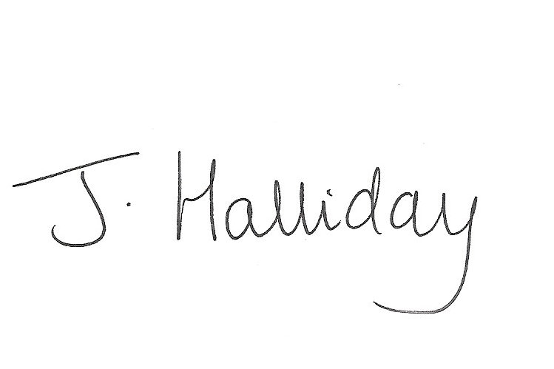
Jackie Halliday
Headteacher

