Monday 14th September
Dear Parents/Careers
It has been a real pleasure having our lovely children back at school and seeing you all -long may it last! The children are doing so well settling back into the new routines and expectations and have adjusted remarkably well to these. We are delighted to extend a warm welcome to our new children in Reception who joined last week. They arrived looking so smart in their uniforms and are already settling in very well.
We will be starting our wellbeing support for those that may need a little extra talk and share time on a one to one with an adult and will let you know if your child will be having this support. Please do keep letting us know of any issues or changing circumstances at home.
Communication
With the recent rising cases of Covid, it is so important that as a community we are following the guidance and advice from the government. I will update you on an ongoing basis.
We will continue to communicate with you via class list (or e mail if you are not on class list) and update you of any changes to the school procedures around Covid safety. Please make sure that you check and read the updates on there, as guidelines are changing all the time.
It is so important, now more than ever, that we are able to get in touch with you at any time of the day –please ensure that your contact details are up to date. We need at least 2 for each child. Mrs Gooday will be sending out a confirmation form for you to return.
The home school contact book will be used so that we can keep regular communication with you–we will be sending home messages for you in there so please read it every day and initial the message to let us know you have seen it. Please also use the book for messages to the class teacher. You can also e mail your child’s class teacher or contact them via the office email or phone with any questions or updates. As we are not currently able to see you in person it is so important that we continue our excellent partnership and keep each other updated.
There are lots of colds and sore throats at the moment –if these have an accompanying persistent cough or temperature or change in sense of taste or smell please make sure you ring the school before sending your child in so that we can discuss the symptoms and make decisions together. Head teachers have requested further clarification around this from PHE(Public health England) and I will send out further information around isolating and testing when I receive it.
Curriculum
Topic letters will be coming out with information about the exciting subjects the children will be studying this term. We will continue to cover all the curriculum subjects, with a few restrictions on how these are delivered and adaptations to how we use and share resources. A key focus this term will be to assess the children’s current attainment in relation to their progress since Easter. We will be putting in place catch-up initiatives to support with accelerated progress for those children who need it following lockdown and partial re-opening. These strategies may be part of class teaching or may be as small group work outside the classroom (we are so pleased to have the lodge!). We will keep you updated about these and now that you are experts in supporting your children (no pressure!) will be involving you in this catch up where possible.
We will also be further developing our remote learning strategies so that these can be triggered straight away if a staff member, bubble or child has to isolate with Covid symptoms. A remote learning plan will be shared with you when completed.
Car park
With your excellent co-operation, the car park is running very smoothly. This works because everyone is following the timetable and procedure. Thank you. Please make sure you maintain the 5 mph speed limit now more than ever as we have children and adults crossing in the path of cars. Please remain by your car at all times –if you have any items for the office these can be sent into school in a clearly labelled envelop or you can call the school to arrange handing this over.
Safeguarding
What to do if your child sees something upsetting online (Safer Internet Centre) https://www.saferinternet.org.uk/blog/advice-parents-what-do-if-your-child-sees-something-upsetting-online
School visits.
This is the time of year when we receive numerous requests from prospective parents to visit the school. Originally we were going to try to manage this through social distancing and enhanced hygiene. However, with the increase in cases of Covid, we have an alternative option. I will be filming a short tour of the school for new parents and offering an additional virtual meeting if also requested. The film will be put on our website for prospective parents to access. As part of this I will be filming the classes at work. Please let me know if you DO NOT want your child to be in this film by Wednesday 16th of this week.

Diary dates
These will look a little different to previous years and will be dependent upon changes to the guidelines. We are aiming to maintain some of our usual calendar events with a different way of working which we will explain nearer the time.
24th September - MacMillan support
This is a charity we support each year usually with our very sociable coffee morning. Unfortunately we will be unable to do this. We could have a design and cake competition for a donation. Winning design for each class receives a cake? Or any other wonderful ideas you may have! Please let me know.
30th September - Harvest
Children will write and share poems/pictures with parents. Food donations for the food bank will be gratefully received and much needed.
15th October Share and learn
We will be sending home a small selection of work chosen by the children for them to share with you.
Week beginning 19th October Parent consultations
We will consult with you on how we can best do this so that everyone feels safe.
- 23rd October Non-pupil day
- 2nd November Non –pupil day
- 3rd November children return
Further calendar dates are on the school website
www.messingprimaryschool.co.uk
Finally, I know that you are aware that the changes to the school routines and procedures have been and continue to be, very challenging and demanding for staff. We have very much appreciated your support and trust in us with the arrangements we have put in place and your positive feedback.
Your sincerely
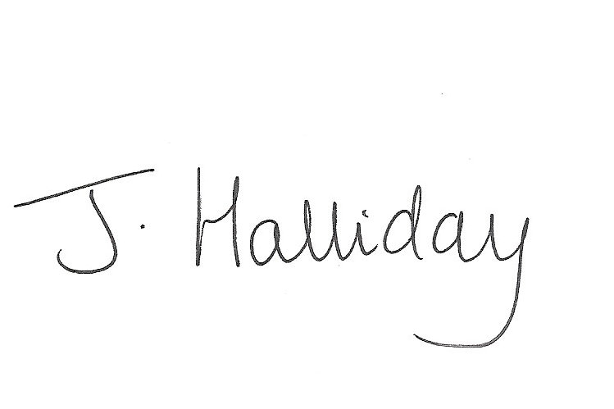
Mrs Jackie Halliday
Headteacher

