Wednesday 15th July
Dear Parents/Carers
I hope you are all finding the changes to lockdown restrictions making your lives a little easier –it’s amazing what a little time with family and friends can do for your wellbeing.
As part of the process of moving out of lockdown and easing restrictions, schools will be open to all pupils from September and there is now a requirement from the government that all pupils attend. (See attached letter from Claire Kershaw, Director of Education). Our last day this year is Wednesday 22nd July and the first day back for the children in Class 1/2/3 is Thursday 3rd September. We are looking forward to welcoming our new Reception children into school starting on Monday7th September.
We are planning for full re-opening for Messing Primary but as you know, with the ever shifting landscape, the situation could change between here and September. We continue to work through the procedures and practicalities of re-opening so that our children, staff and families are as safe as we can be. Some of these I am able to share with you now, and will keep you updated with further information.
But before that, I want to share some fantastic news! We have been discussing the possibility of an additional space for the children for a long while and are delighted that we are able to put in a new ‘lodge’ into the school grounds with funding from the PTA and savings made ; resources budgeted for have not been needed during the lockdown and school closure. The lodge will be put in place in the last week of the summer holiday (subject to planning permission) and is a space we can use all year round. It’s so exciting! (See attached information for further details)
Arrangements for September:
Drop off and pick up
This has been one of our biggest challenges to organise. We have planned a staggered timetable for drop off in the morning and pick up after school with different arrival and pick up times for each class. This involves younger siblings waiting in the car with parents until their time for drop off. Unfortunately, there can be no flexibility with this as it is very detailed and complicated to manage. Whilst we understand that this is not ideal, it is the only way that we can manage the amount of cars/adults and the need for separation of the bubbles; we ask for your continued understanding and patience. We will review this system after a few weeks.
Separate sheet with information about timings and procedures to follow.
How will the children be organised?
The children will continue to be in their bubbles, but the size of a bubble can now be whole class. There is no longer a 2m social distancing requirement within bubbles, but staff: staff and staff: children should maintain as much of a distance as possible. This means that the children in different classes will not be mixing at lunch and break times and there will be no whole school meetings such as assemblies. We are aiming for whole school praise assemblies via zoom and other assemblies held in classes.
Due to the very small size of the EYFS area we will be organising the children as follows for the Autumn term initially:
- Reception to be based in the hall and use the EYFS outdoor space.
- Class 1 to remain in class 1 and also have the option of a small group/s accessing the EYFS room.
- Class 2 to be based in class 2 with the option of using the lodge for 2 days for small groups.
- Class 3 to be based in Class 3 with the option of using the lodge for 2 days for small groups.
Classrooms will be organised to minimise contact as far as possible; this is obviously not possible between younger children hence the bubbles.

Lunchtime and break time
Break time will be staggered with Reception having their snack/break/lunch in the hall and EYFS outside area.
Class 1 and 2 will have their break at 10.15-10.30
Class 3 will have their break from 10.30-10.45
Children will eat lunch in their own classrooms as bubbles cannot mix. We have staggered the break and lunch time so that R/Class 1 and Class 2 will have lunch from 11.45-12.45. Class 3 will have their lunch from 12.15-1.15. This allows for different areas of the playground and field to be available to classes separately.
For safety and practical reasons school lunches will be packed lunches individual bags.
A flyer with information about these will be coming out.
What will they need?
Children will be back in their smart school uniforms from September.(Please let me know if you are having financial difficulties as we may be able to support with school uniform and sign post the community support available).
They will need a water bottle as the school fountains will not be in use.
They will also need a small school bag with their reading book/home school diary/snack and packed lunch if they are bringing their own. They MUST NOT bring pencil cases, toys, soft toys or large bags. There is clear hygiene advice around sharing soft toys and shared equipment as well as limited storage space in the corridors.
How will we manage risk and try to keep them safe?
- Children will be taught in the same class group or bubble throughout the day.
- They will stay in their bubble for all activities
- They will stay in the same room. Where groups may use the wellbeing room/lodge they will only be with children from their own class and these area will be wiped own after each use.
- They will have their own entrance and exit to use throughout the day
- Groups will access their allocated toilet area during the day (with no mixing of bubbles).
- Children will have their own learning packs –no soft toys or furnishings in the classrooms.
- Items will be cleaned or quarantined after use.
- We have a cleaning and hygiene plan in place for ongoing cleaning throughout the day
- Restrictions on visitors
It is so important that we keep our partnership with you working as closely as it has been, on the children’s return. You are the experts on how your child has been and is now finding things. If you are aware of any incidents, experiences or their feelings about lockdown which may affect your child’s wellbeing on return to school, it would be very useful to know before the start of term so that we can offer support if needed and be aware. Please e mail either the class teacher or myself in confidence.
I will be sending out further information before the return on September 3rd .
Hoping you are all keeping safe and happy.
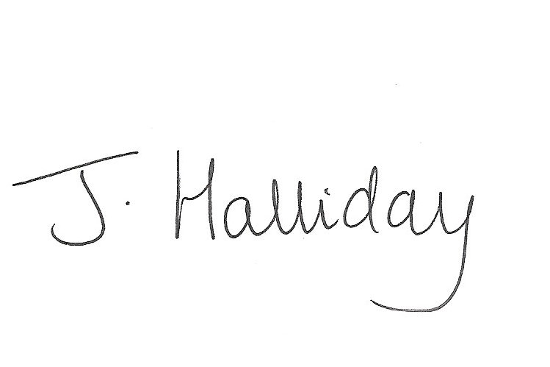
Mrs Jackie Halliday
Headteacher

