Monday 28th September
Dear Parents/Carers
We have successfully navigated a few weeks with the complications of the additional requirements of Covid and are all still smiling! Thank you so much for your support and positivity. I am so impressed with the attendance figures and can see that you are all taking a very sensible and informed approach to colds and sniffles and communicating with us where you are not sure. Erring on the side of caution is best and the school is following the very clear guidelines on how to support you. The whole school risk assessment is regularly reviewed and is available if you would like to see it.
Governing body vacancy
We currently have a vacancy on the governing body as one of our parent governor’s 3 year term of office is completed this October. They are happy to renew their position and equally happy for someone else to take over. If we have interest from more than one party this would then go to a ballot.
If you would like to put yourself forward for the positon please let me know by Monday 5th October.
The governing body are continuing to meet virtually, and to discuss the strategies the school has in place for school development and managing the current situation.
Governors’ Report
Our first governing body meeting of the new school year was held via Microsoft Teams on 15th September. We have been very pleased to welcome all our pupils back to school and our new pupils into the Messing School family and we commend all your children for how they have adapted to the new school routines. We also thank you for your support of our school staff in these challenging times.
At our meeting we received a full report from Mrs Halliday on the school re-opening. We heard about the challenges the school faces and expressed our support for Mrs Halliday and all the staff. We also reviewed all the Covid-19 risk assessments and updated the School Development Plan and School Vision with new priorities for this year. We approved the revised Child Protection Policy. Anne-Marie Renshaw was re-elected as Chair. We will have a vacancy for a parent governor from October. Please contact the school office if you would be interested.
You can contact the governors through the school office if you would like to speak to us about any queries or concerns you may have.
Admissions to secondary schools
The admissions round for applying to secondary school opened on 11th September and closes in 31st October. Please apply online at https://www.essex.gov.uk/apply-for-a-secondary-school-place
Schools are managing their ’visits’ in different ways so please go to the secondary schools’ websites for details. (Please be aware that Thurstable virtual open evening is Tuesday 29th September)
Admissions to primary schools open 9th November and close on 15th January. All applications can be made online at https://www.essex.gov.uk/apply-for-a-primary-school-place

Smiley Club
We are very pleased that we able to continue to offer this before and after school provision to support parents. However, please be aware that should Miss Robertson need to isolate we may not be able to offer the provision beyond a couple of days’ notice until she returns. This will depend upon staffing levels. I am letting you know so that you can start thinking of contingency plans should this arise. (Obviously we are hoping that this won’t be necessary).
School dinners
We have been considering manageable ways of increasing the menu choice and the children have expressed their preferences to Mrs Owens, the catering manager. We will therefore be making some additions to the dinner menu. Along with the packed lunches on offer we will also add the option of sausage rolls on Tuesdays and Pizza on Thursdays. This will start from the week beginning 5th October and the menu will be sent home in the children’s bags.
Healthy Snack Reminder
A healthy piece of fruit or vegetable at break time gives your child a boost for their next session of learning: The following are allowed at break time:
- Fruit
- Vegetable sticks (with hummus)
- Dried fruit
- Rice cakes
- Breadsticks
- Crackers/Cheese
- A small sandwich or roll. (Not jam)
- A healthy cereal bar(Not chocolate covered)
WE ARE A NUT FREE SCHOOL.
Please be aware that many cereal bars are packed with sugar and not necessarily a healthy option; whole grain granola bars that are low in fat and sugars are the better option.
Please NO sweets/chocolate bars or crisps for snack time.
Car Park safety
Thank you for reversing into the car parking spaces, as this is safer for the children and staff crossing the car park. Please refer to the ‘Safe use of the car park’ policy on the school website and let anyone who is bringing or collecting your child know the schools safety procedures. Remember there is a 5 MPH limit for everyone’s safety (even if you are running late).
Online safety
Protecting personal data
We all know the obvious information that we shouldn’t share online, but just how can you protect your children and ensure they are not sharing personal data? The National Online Safety team has created a useful guide to help parents and carers understand exactly what they can do to help protect their children’s personal data online. The guidance is FREE to download, you just need to register on the site.
https://nationalonlinesafety.com/guides/protecting-personal-data

Remote learning plan
As part of the school strategy for supporting with continuity of learning in the event of a partial or full lockdown, or in the event where a child/ren need to isolate for 10 or 14 days, we have further developed our remote learning plan which will support with this. This is available on our website. Your feedback from the lockdown period was that you felt very well supported and had plenty of focused activities for supporting your child across a range of subjects. To develop this further, we are aiming to use google classroom (some of you are familiar with this from your children’s secondary schools). This would additionally allow for feedback and marking of work too. The challenge of this will be to maintain class teaching and provide home learning linked to this (while not overburdening teachers with additional workload.)We are yet to have the training and to roll this out step by step across the school; in the meantime we have resources and strategies in place to support you and the children in the remote learning plan which is on the school website.
Reminders
As the weather is now turning colder, please make sure you send in a warm/waterproof coat for your child.
Yours sincerely
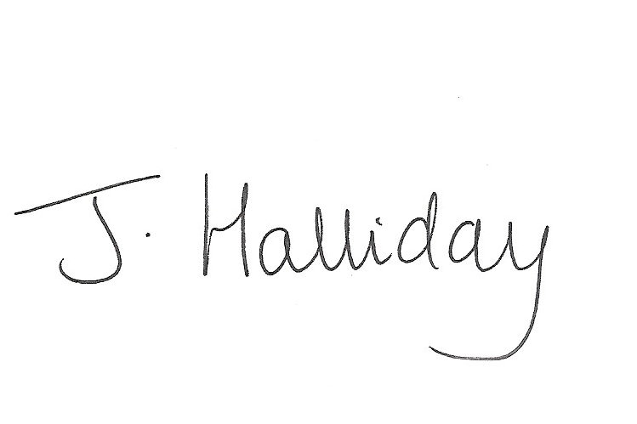
Mrs Jackie Halliday
Headteacher

