Dear Parents/Carers
Thank you for showing an interest in our lovely school. I’m sorry that due to the current restrictions we aren’t able to show you around at the moment. We are hoping that this will be possible in due course. Thank you for your patience and please find below the link to our virtual tour.
https://drive.google.com/file/d/1IzQCQzdJg2HQ3T9yF8aJ44U_c4mRJw6l/view?usp=sharing
The following are the most frequent questions I’m asked when showing prospective parents around, but you may well have some of your own specific to your child and your circumstances.
Frequently asked questions
When will my child start school?
We usually settle the rest of the school in for the first couple of days back in September. Reception children start for a couple of mornings, then we add in staying for lunch for a coupe of days and finally they stay all day. Sometimes they can be quite tired so we are always happy to have a chat with you about how they are and be flexible with this where needed.
Will they meet their new friends and the teachers beforehand?
Yes. We offer getting to know each other sessions where you and your child can come into school and play (great fun!) for an hour a week for the 5 weeks preceding the summer holidays. This gives you chance to meet the class teachers, ask any questions and get to know the other children and other parents. Your child will be able to play with their new friends and feel more confident when they start in September.
How will you let me know how my child is getting on?
We have a close partnership with our families and are always happy to have a chat. The Reception class teachers will keep you updated on how your child is doing though:
- Regular informal chats at pick up time about how their day has been
- Tapestry –an online programme which allows us and you to share photos and information about your child’s learning and key milestones on a daily basis.
- Notes in our home/ school communication book
- Stay and play sessions(you are invited into class to be involved in their learning)
- We are also always available by phone/e mail.
Will there be place for my child at Messing?
We have an intake of 12 pupils, these come from a wide surrounding area including (Witham, Tiptree, Great Totham, Mersea, Tollesbury and Messing) Most people who put the school first in their choice will get a place –please bear in mind this can’t be guaranteed and depends on demand. (Essex manage our admissions for us –please see our policy on the website)
Please see the information sheet ‘How to apply for a place at Messing Primary’
How will my child be supported with their learning?
- LSA’s(learning support assistants) are in each class base throughout the school so that there is a good adult child/adult ratio.
- Our class sizes are small.
- Children have a great start with just 12 children in their class. They then move into Class 1 which has Year 1 and 2 combined. As they progress through the school the older year group moves up each year.
- Teachers meet with the Headteacher each term and talk about every child. If they are above or below their age expected levels we put in place additional support to make sure that learning is tailored to their needs and that they meet their full potential.
- We focus on the whole child –their emotional and social development as well as academic learning. Our growth mind set approach encourages children to be reflective learners, to persevere with challenges and to celebrate their successes when they have overcome these.
- Mrs Gooday (our office manager) and I are always at the end of a phone should you have any worries or concerns. Good home/school communication is the key to a happy child!

Can parents come in and join in with the learning?
Yes please! We have a very helpful parent who runs our library for us. Another parent has trained in mindfulness for children and delivers courses in school with the children. We have a regular team who come in to support with reading with the children. You may also be called upon to join the children in class to share your skills and knowledge with them where this ties in with their topic.
We run regular parent sessions in class where you can join your child in their class for maths or English lesson and see what strategies we are using to help your child. Hopefully these can then be used when you are helping your child with their home learning
Will my child have less opportunities in a small school?
Far from it –in fact the opposite. As we have fewer children the children have the opportunity to be involved in far more events and experiences.
Sport:
As well as our partnership with New Hall School, we are part of a large consortium of 24 local schools. Children across the year groups take part in inter-school events and competitions such as cross country, netball, cricket, rugby and athletics. The Reception children also have an inter school sports festival at a local school. All the children have a term of swimming each year at New Hall School. Our sports clubs include martial arts, football, multi skills, tennis, and dance. We also offer taster session of less familiar sports (e.g fending/archery/golf) to give children the opportunity to then take this up out of school or later in life.
Music:
We are a musical school with children able to learn a range of instruments through Essex music service who come into school to offer individual tuition. Whole classes also have chance to learn an instrument-these have included recorders, ukuleles and clarinets. We love singing for the joy and mental wellbeing it brings. Our choir has over 30 children attending who then have the opportunity to join the young voices performance at the 02 with over 4000 other children. A truly magical experience. We also have a range of singing workshops from the Big Sing group and I sing pop. Music clubs include drumming, glockenspiel and recorders.
Visitors and visits
We have our residential visit once every 2 years so that all children have the chance to enjoy this. Each class has at least one visit each year linked to their topic and the whole school goes to the pantomime. Children have visits from a range of support services and charities, helping them to keep safe and to become active citizens through raising money for these through events they have planned and organised such as our annual Macmillan coffee morning.
School events
The active PTFA organise fun events throughout the year and performances and celebrations take place in the school hall and local church.
There is a lot happening at Messing Primary!
And finally…
Where do I park?
I understand that this is an important question as nobody likes to start the day with congestion and parking nightmares!
Do not worry! We are in the very fortunate position of having 2 car parks. One at the side of the school building for the staff to use and the other a large car park on the right hand side of the school (as you face the school).

Please take the time to have a good look at the school website as this has plenty of further information about us.
Hopefully this FAQ sheet will answer the most questions for you, but please do call or email the school if you have any questions and I will be very happy to have a chat either by phone or zoom.
Yours sincerely
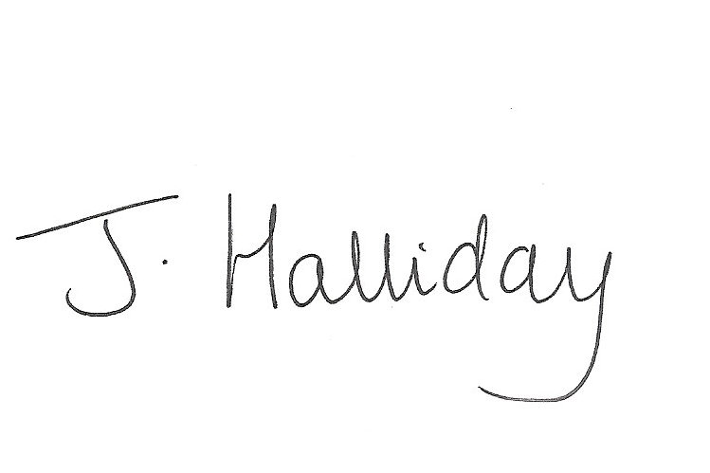
Mrs Jackie Halliday
Headteacher

