Dear Parents/Carers

Welcome back. I hope you have had a happy and healthy half term. You will be aware that the country will be in lockdown again from Thursday 5th November. Schools will remain open and unlike the first lockdown in March, there is a requirement that all children continue to attend. I understand that for some families another lockdown may well put an increased strain on the wellbeing of family members as well as family finances. Please do call us if you are having difficulties and we can sign post you confidentially to some support –we are also here to lend a sympathetic ear and advise where we can. I understand you may have increased concerns about your child being in school. Please be assured that we are continually being updated and following all recommendations and guidelines. Despite the increased measures nationally, we are pleased that we will be able to continue to offer some normality to the children and to support you and the children by continuing with their education in school. They gain so much from being here not just with their learning but also being with their friends and having consistency to their day.

Thank you for your continued support and positivity; it is very much appreciated.

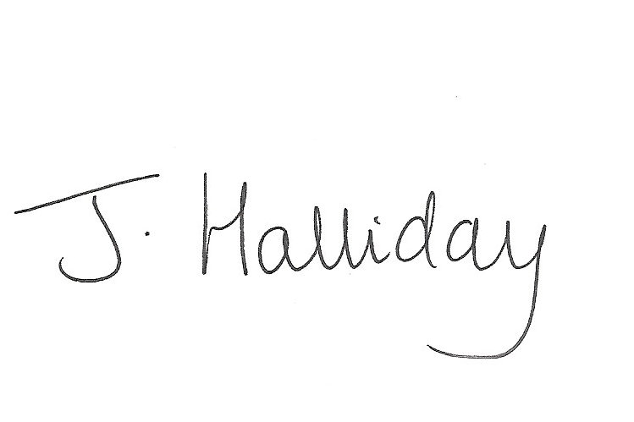

Kind regards

Jackie Halliday

November 3rd 2020



**Parent survey**

We will be sending out a revised version of our annual survey to include questions about home learning and support during lockdown. Thank you for completing the recent contact information form and telling us about your IT access and issues .The information you sent in has helped us to tailor our home learning plans to support as best we can should your child need to stay home isolating.

Please make sure that all contact details are updated as needed so that we are able to get hold of you at short notice should we need to.

Should we need to send home a class or even the school (hopefully neither of these) we will contact you via classlist. Please make sure always you pick up these messages straight away. If you are not on classlist we will contact you by phone.

**Virtual Tour**

You may remember I sent out information regarding plans for a virtual video tour of the school as we are restricting visitors and can’t show prospective parents around our lovely school. We have put together (after several attempts!) our virtual tour of the school. As you haven’t been able to come into school for so long, I thought you would also like to see your lovely children their classes. Please click the link below. <https://drive.google.com/file/d/1IzQCQzdJg2HQ3T9yF8aJ44U_c4mRJw6l/view?usp=sharing>

**Parents Consultation Meetings**

Many thanks to New Hall School for supporting us with setting up the video linked parent evenings. For the vast majority of parents the signing up process and meetings themselves were very smooth.

**Parent Governor Elections**

Thank you to those who have sent in your ballot papers already. Please make sure these are returned by Monday 10th November

**School Canopy**

We are currently offering martial arts in the morning for Class 3 and have just increased this offer to Class 2 also. The numbers are restricted for safety reasons and where possible this will take place outside. Where poor weather does not allow us to be outside, we will use class 3. We are aiming to increase our sports offer later in the term by having a small canopy erected over part of the playground. This will ensure that the children are able to have their much needed exercise outside whether it be PE or break and lunch play times and may allow us to introduce further sports clubs.